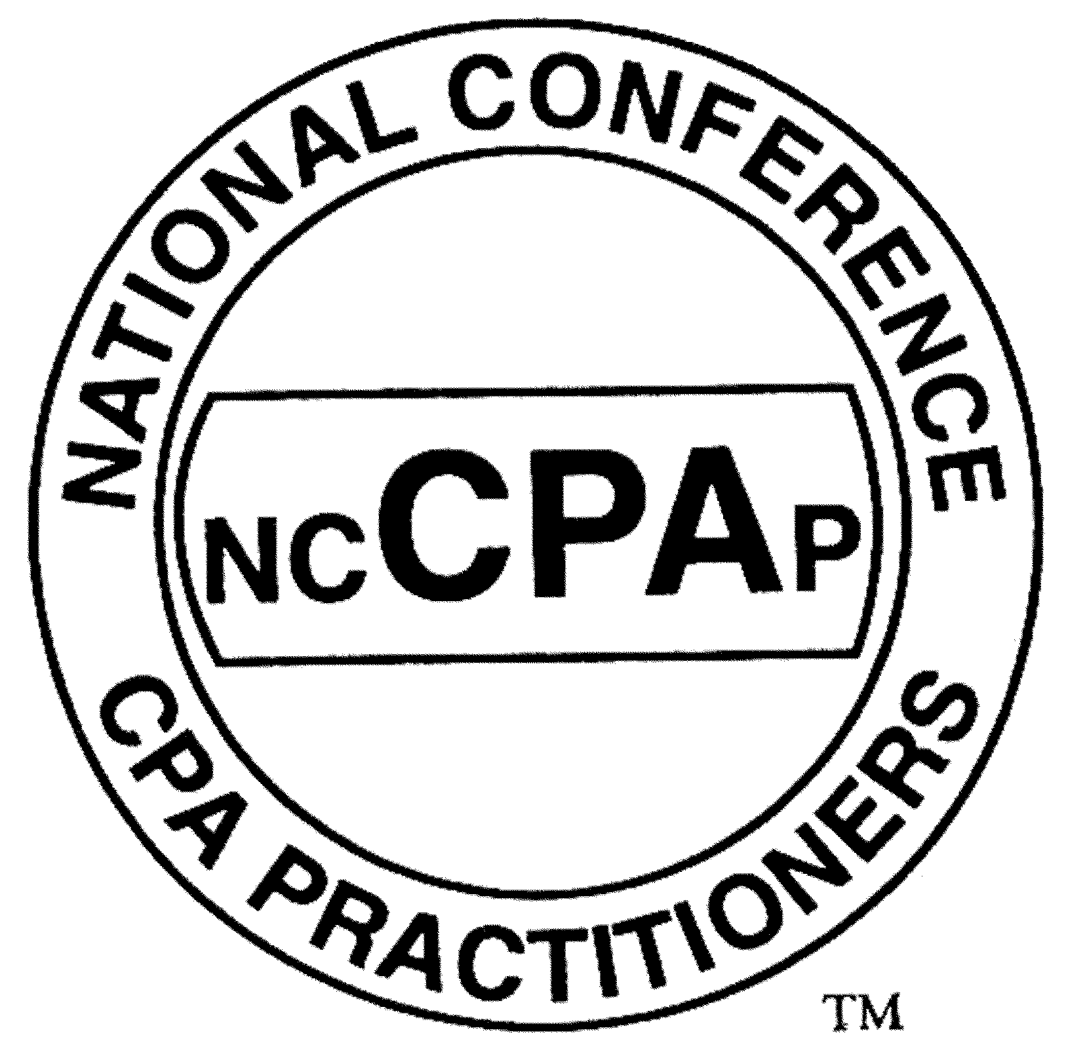

The National Conference of CPA Practitioners, Inc.
and

The American Institute of Certified Public Accountants

Scholarships for Graduating High School Seniors – 2007

Competitive merit-based awards of $1,000 each for outstanding graduating high school seniors planning to pursue a career as a certified public accountant.

Please read these instructions carefully before you begin to complete this application. The National Conference Of CPA Practitioners, Inc. cannot process, and must destroy, incomplete or incorrectly submitted applications. All applications must be received by May 1, 2007.

Student Eligibility Requirements:
- Be a graduating high school senior.
- Have a grade point average (GPA) of at least 3.3 on a 4.0 scale.
- Have applied to or been accepted at a two or four year college.
- Be enrolled as a full-time student.

Payments:
Awards are made for the academic year following application, and will be sent directly to the school for credit to the account of the student recipient.

Instructions:
- Complete all sections of the application form attached.
All responses may be typed or neatly printed, except signatures. The essay must be typed.
- Your school guidance counselor must verify and sign section B.
- You must submit the most recent copy of your high school transcript.
- Before mailing your application package to us, make sure that you have included all documents.

All material must be received by May 1, 2007 to:
National Conference of CPA Practitioners, 22 Jericho Turnpike, Suite 110, Mineola, NY 11501 Attention: Scholarship Committee

For Further Information or questions please call 888-488-5400 or email lanak.ncCPAp@verizon.net. Please visit our web site at www.nccpap.org

The National Conference of CPA Practitioners, Inc.
and

The American Institute of Certified Public Accountants

Scholarship Application 2007

Section A:

Name:___________________________________________________
First Mi. Last
Address__________________________________________________
__________________________________________________
Telephone: (_____)____-____________Email___________________

Section B: This section must be verified and signed by school guidance counselor.

Overall Grade Point Average: __________
SAT Scores if available: Math_____ Verbal______ Written______
ACT Scores, if available:________________

To the best of my knowledge, the above grades accurately reflect the student’s academic standing.

___________________________________ __________________________
Signature of Guidance Counselor Name (Please Print)

Telephone: _____________________ Date: ____________________
Email: _____________________

Section C:

Attach a typed essay. The essay must be at least 200 words and must explain why you desire to pursue a career as a certified public accountant. Please include your name and email address on essay.

