Contact:
Shari Goldstein 516-433-5502 shari@goldsteinPR.com
Holly Coscetta 516-333-8282 execdir@nccpap.org

National Conference of CPA Practitioners (NCCPAP)
Awards 16 Scholarships in Joint Program with AICPA

MINEOLA, NY – June 21- The National Conference of CPA Practitioners (NCCPAP) and the American Institute of Certified Public Accountants (AICPA) have awarded 16 scholarships to graduating high school seniors, the largest number of scholarships since the competitive merit based awards program began. Presented to students in ten states, the awards are part of a joint educational program designed to encourage students who have decided to become CPAs.

“It’s very exciting to see growth in both the number of recipients and the number of applicants,” noted Carol Markman, NCCPAP president. “These generous awards, which are sent directly to the college account of the student recipient, send a strong signal that ours is a profession that encourages and supports their success.”

To apply for the scholarship, students must be graduating high school seniors with a Grade Point Average of at least 3.3 on a 4.0 scale, have applied to or been accepted at a two or four year college or be enrolled as a full time student. They were asked to write a short essay on why they chose to become CPAs.

Many were first exposed to accounting through introductory high school classes and found that they loved the problem solving and analytical aptitude needed to be a successful CPA. They participated in internships, worked in family businesses, held after-school jobs in accounting firms, or attended special educational programs through professional organizations. Others view becoming a CPA as an advantageous credential with which to enter the business world. All of the students are very clear that their intention is to have successful careers and becoming a CPA is a big part of their plans.

NCCPAP extends its congratulations to the 2005 scholarship award recipients. Biographies and photos of each student appear on the pages that follow. The winners are:

Brandy L. Bianchi – Lakeland, FL

Michelle L. Bullard - Orlando FL

Jessica M. Cusick - Clackamas, OR

Jessica Elena Diaz - Lawrence, KS

Kerina Ellis - Miami, FL

Tiffany Hsueh - Richmond Hill NY

Christopher J. Janus – Seaville, NJ

Shafayat Joarder - Brooklyn, NY

Seth Brian Leibert - New City, NY

Megan E. Myers - Zanesville, OH

Deanna M. Orwig - Hillsboro, MD

Matthew P. Pavlis - Holbrook, NY

Keri J. Wasson - Rockville Centre, NY

Laura B. Wiest - Yakima, WA

Hong Zhu - Glastonbury, CT

Christina M. Nelson - Ridgely, MD

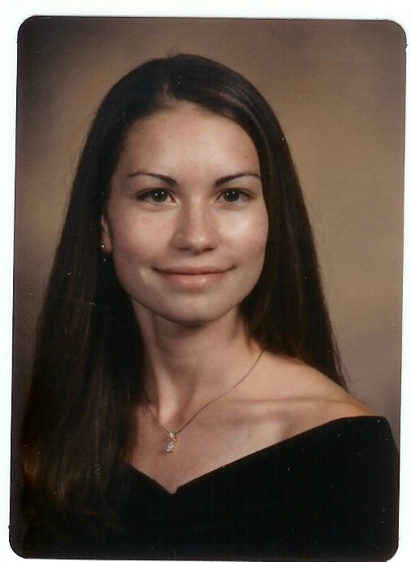
DEANNA ORWIG has lived in Caroline County, Maryland for seventeen years. She is an only child whose hobbies include art, crafts, and outdoor activities.

In High School, De Anna was a runner of indoor and outdoor track and participated in two years of cross-country and soccer. She also participated in such clubs as Future Business Leaders of America and Prom Committee and is a member of the National Honors Society and the National Technical Honors Society.

DeAnna graduated from North Caroline High School and will major in Accounting at Salisbury University in Salisbury, Maryland in the fall. After earning her degree, she plans to become a Certified Public Accountant.

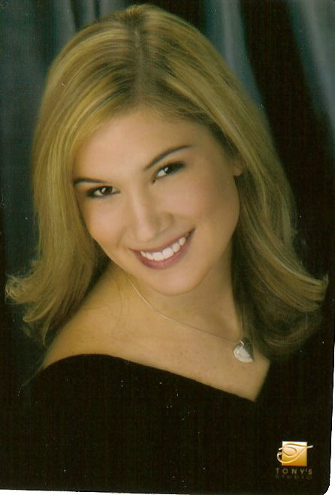
BRANDY BIANCHI is from Lakeland, Florida. She recently graduated from Lake Gibson High School and will be attending Stetson University in the fall.

Brandy has been involved in accounting since the tenth grade and plans to pursue a career as a CPA. Brandy states “Stetson has an incredible business program and accounting is a very popular major there.”

Brandy is very eager to pursue her dreams and is grateful to the NCCPAP and the AICPA for helping to blaze the trail into her ideal college where she hopes to make them proud with a degree in accounting.


TIFFANY HSUEH is a native of New York and lives in Queens with her parents, two sisters, two parakeets and her pet poodle named Kibbles. Her favorite activities are reading, painting and roller skating. She also enjoys going to the movies, shopping and surfing online.

Tiffany was an honor roll student at the High School of Economics and Finance and in the fall, plans to attend Lehman College where her goal is to become a C.P.A. After graduating from college, she plans attend graduate school to gain her MBA degree.

_______________________________________________________________________

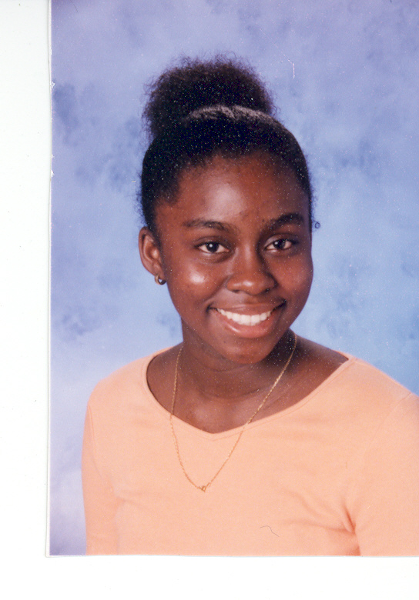
KERINA ELLIS was born July 1987 on the small isle of Grenada in the Caribbean. She has a younger sister whom she is very close with. As a child she was shy, but as the years went by, with her parents’ influence she has become more outgoing.

Kerina, her parents, and her sister moved to Miami in 2002 to obtain a good education in America. Kerina states “The education system in America is very different from those in the Caribbean and also more challenging. I was exposed to many different career paths, but accounting is the only one that gives me satisfaction.”

Kerina will attend Florida State University in Tallahassee, Florida in the fall. She plans on getting her MBA with a concentration in accounting and also a CPA license.

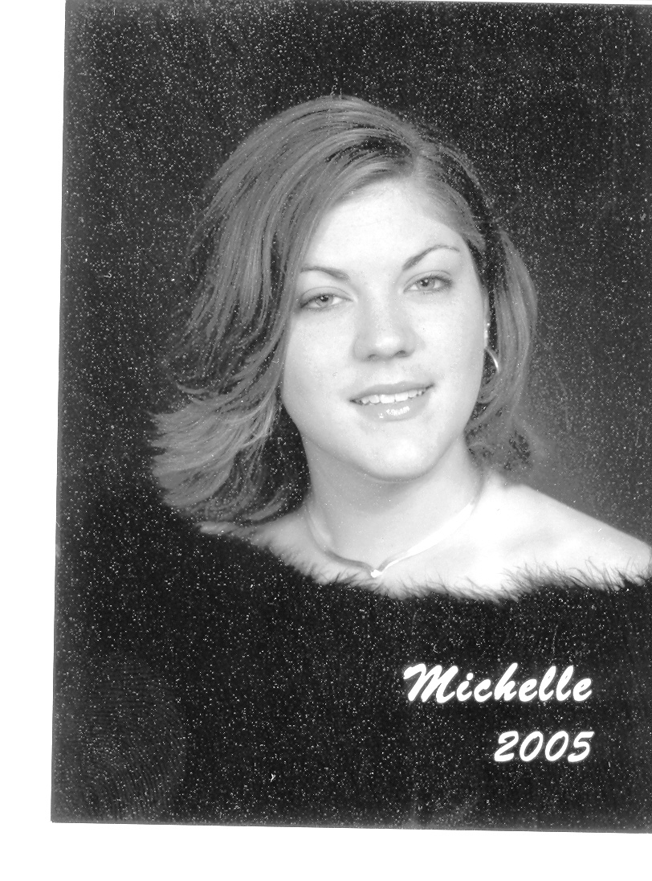
MICHELLE BULLARD was born and raised in Orlando, Florida. For the past four years she has been in the Academy of Finance at William R. Boon High School. In her sophomore year, she worked 100 hours at Orlando Regional Medical Center as a volunteer. Then in her junior year, she worked as a Volunteer Income Tax Assistance (VITA) for the IRS. Along with her fellow peers, she performed tax returns for lower socioeconomic families as well as students on the Boone Reservation.

Michelle has worked at Old Navy, and at EXP Staffing, where her duties included providing statistical analyses' for the company through intricate spreadsheets, updating QuickBooks and other basic administrative tasks. Additionally, Michelle helped construct the 2004 Profit and Loss Statement, along with the Balance Sheet and helped with the filing of the 2004 tax return.

In the fall, Michelle will attend the University of South Florida, enrolled in the Bulls Business Network and majoring in Accounting.

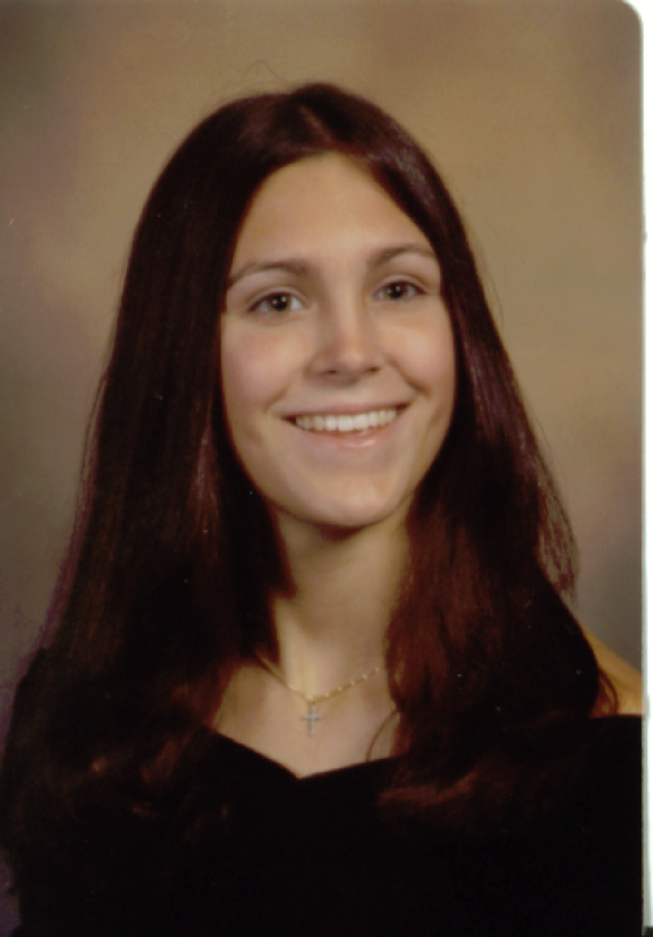
CHRISTINA NELSON is from a small town in Caroline County. She lives with her Mother, Father, older brother, cat and dog.

Christina attended North Caroline High School and was involved in Field Hockey and the Drama Club for all four years. She received the MVP Award and the Coaches Award in field hockey and has won multiple honors and awards for being in drama, including the Excellence in Acting Award, Best Actress Award, and she received two honor bars from the International Thespian Society for being involved in theater for 1,100 hours.

Christina focused a lot of her classes on business, taking accounting I, II, and III and also marketing and speedwriting. For tax season, she worked at CBIZ Beatty & Satchel and currently is working as a secretary at Halloway and Associates, Inc. Christina’s plans are to attend Mount St. Mary’s University and major in accounting. After receiving her education, she plans to become a CPA and possibly own her own business.
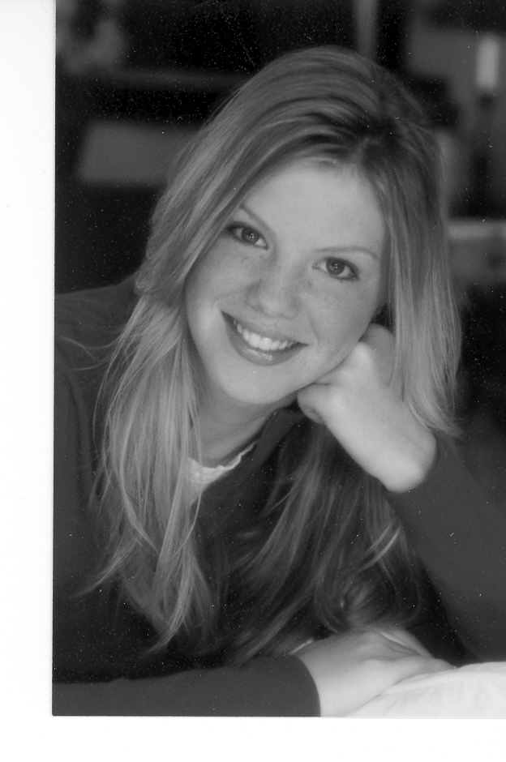
JESSICA CUSICK lives in Clackamas, Oregon, a suburb of Portland. She has two sisters, Jenny and Megan.

As a graduating senior of Clackamas High School, Jessica was greatly involved in athletics and was a member of DECA, an association of marketing students, and served as the Clackamas High School DECA President.

An active member in the National Honor Society, Jessica maintained a 4.0 GPA through all four years of high school and served as one of her graduating class' valedictorians. Post graduation plans include attending the University of Oregon where her major will be accounting.


SHAFAYAT JOARDER graduated Fort Hamilton High School in Brooklyn, New York.

He was a Full-time Intern at Salomon Smith Barney, Citigroup, and volunteered as a Legal Assistant at Asian American Legal Defense and Education Fund and also as Secretary at Fort Hamilton High School, Academy of Finance.

Shafayat was President of the Chess Club, and a member of the National Honor Society. In the fall, he will attend New York University and major in Accounting.

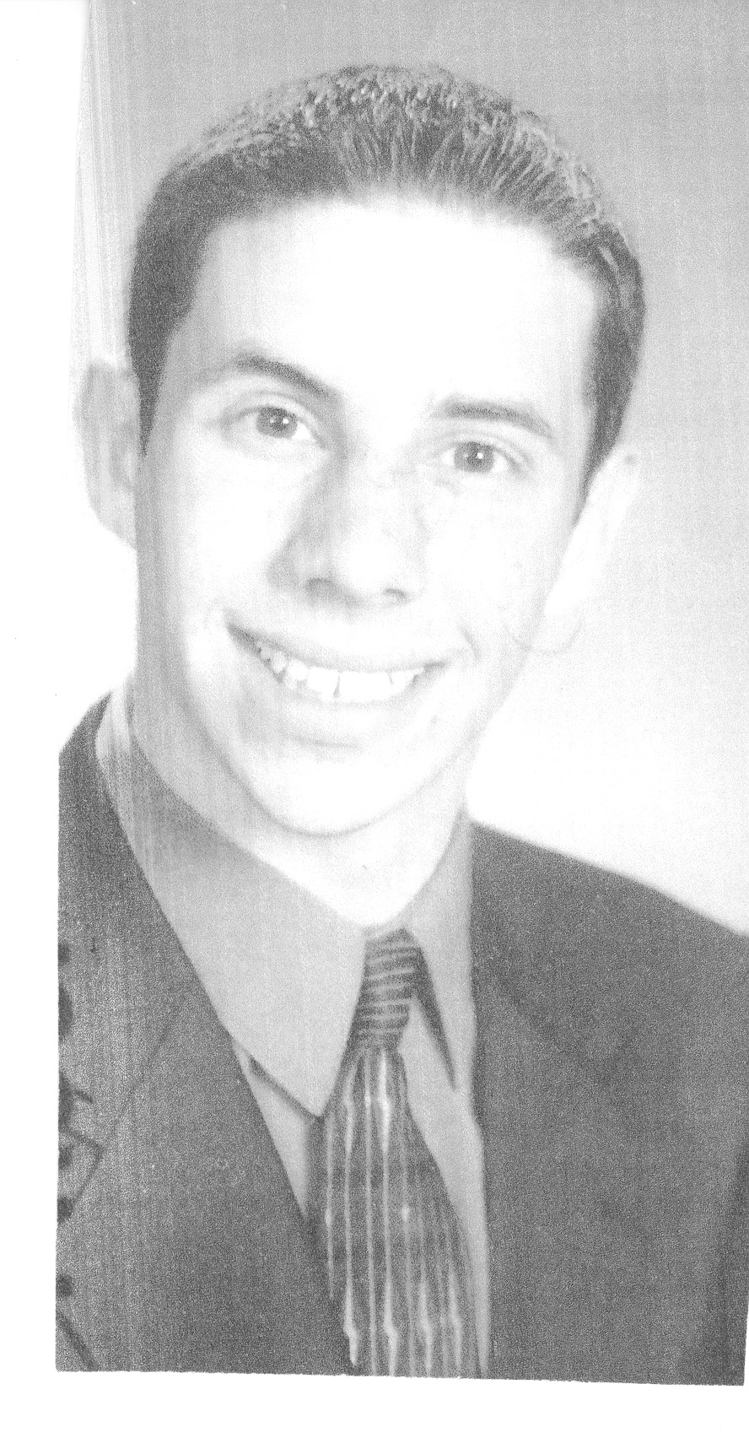
SETH LEIBERT graduated from Clarkstown High School North and consistently ranked in the top 10% of his class for academic performance throughout his four years of high school.

Seth further challenged himself by applying to the Mentor Honors Program at SUNY Rockland as part of his senior year of high school. Here, he competed with other seniors and took college level courses while still a senior in high school. His successful academic career has been recognized by his involvement in the Math and Social Studies Honor Societies, his membership in the National Honor Society, and his attendance at the Academic Banquet as well as many other academic clubs and activities. Seth has taken a variety of honor, college and AP classes during his high school career which included Calculus, Physics, College Accounting, Model Congress, Mock Trials and Process in Government, Economics, AP History, Sports Medicine and Psychology.

He will attend the University of Michigan in the fall where he will study accounting and finance in the Ross School of Business.

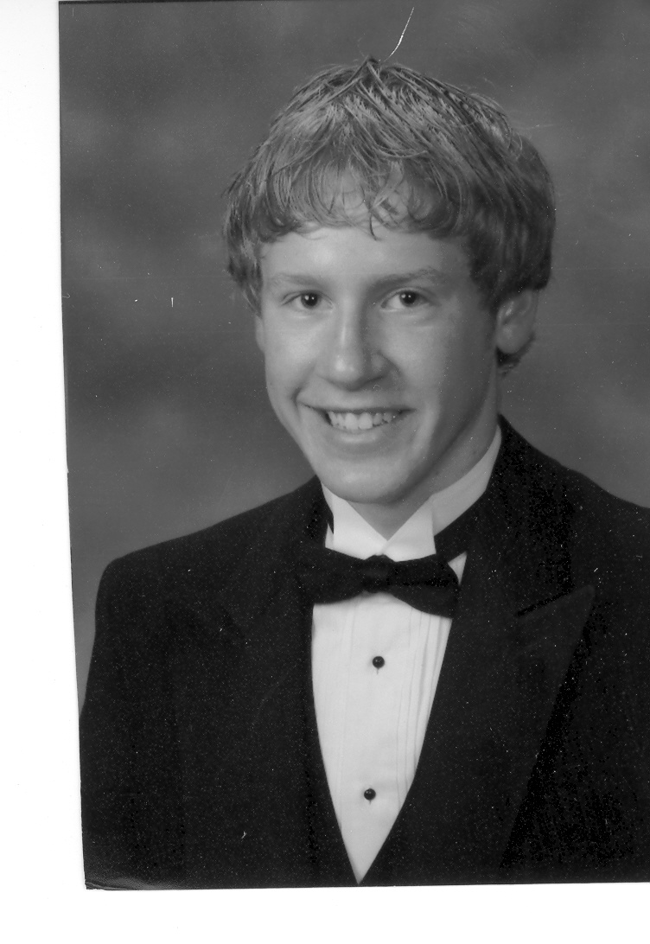
MATTHEW PAVLIS graduated Sachem High School East in Farmingville, New York, where he ranked number thirty-two out of 543 students with a 108 weighted grade point average.

Matthew was an active member of both the National and Foreign Language Honor Society, and a National AP Scholar. Outside of school, he enjoyed doing community service projects in his local parish and with Sachem East's Student Government.

His hobbies include playing volleyball, reading, and fishing. This past summer, he was selected to the New York State Greater Binghamton Empire State Games for volleyball and was also the captain of Long Island Volleyball Club
18-1's team that placed second at the East Coast Championships last May.

Recently, Matthew participated in the New York State DECA Career Conference and placed top ten in the advanced accounting event. He was also selected as Johnson and Wales University's Top Ten national Outstanding Student Leaders of the Year. This fall, he will attend Loyola College in Baltimore, Maryland for his undergraduate studies and aspires to work in forensic accounting.

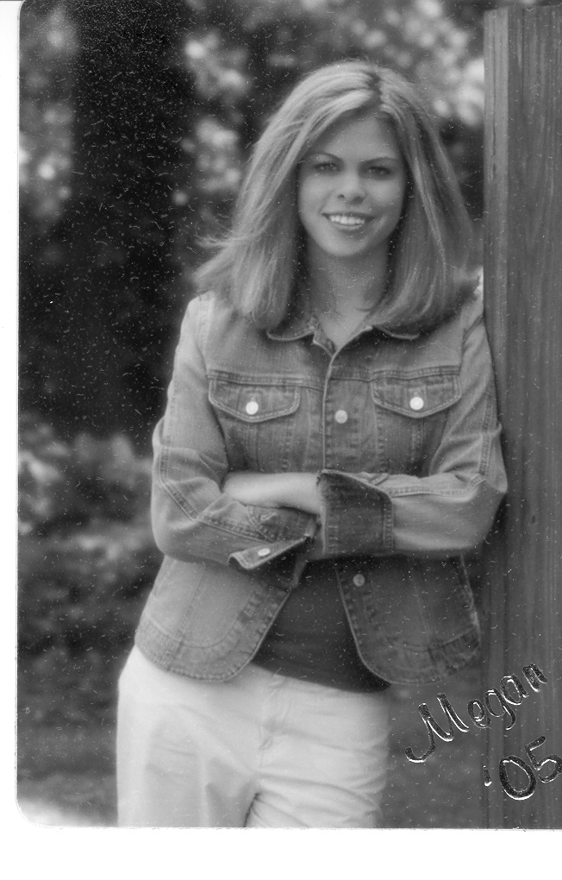
MEGAN MYERS graduated West Muskingum High School in Zanesville, OH. She has been actively involved in the Muskingum County Community Youth Foundation, an organization of high school students working to energize and empower area youth, over the last four years. In 2004, Megan served as president and led the board in distributing over $15,000 in grants to programs to help children.

At West Muskingum, Megan led the local chapter of Future Business Leaders of America (FBLA). She also served as the Ohio FBLA State President and FBLA North Central National Vice President. Megan has received awards at the State and National level in the FBLA competitive events program and completed all four levels of the Business Achievement Awards, the organization's individual membership recognition program. She also served as the National Honor Society President and is a member of TEAMS Math and Science. Megan is a Hugh O'Brian Youth World Leadership Congress alumnus.

This fall, Megan will attend the University of Pennsylvania to study at the Wharton School of Business. One day she hopes to work in a nonprofit organization benefiting the lives of youth everywhere.

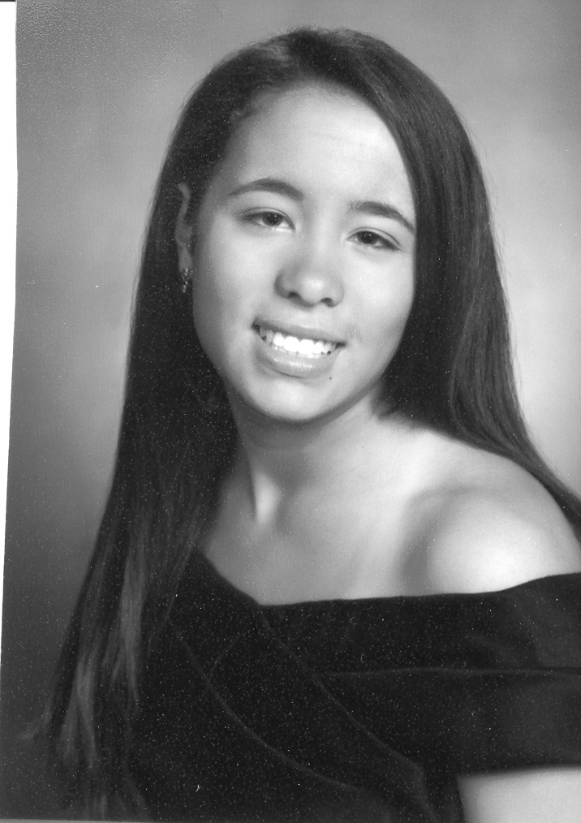
KERI WASSON was born in Oceanside, New York and attended St. Agnes Cathedral School in Rockville Centre. She was a member of the swim team at Freeport recreation for several years, participated in soccer, and studied ballet and piano.

Keri graduated from Sacred Heart Academy in Hempstead, New York where she was a member of the National Honor Society. She was co-captain of the Cross Country team and a member of the winter and spring track teams. She has maintained her service to the church by continuing as a Bishop's Server, and donating her time to the “Meals on Wheels” program.

Keri will attend Long Island University, CW Post Campus in Fall 2005, where she has been accepted into the five year Honors Accounting Program.



HONG ZHU was born in Hunan, China. At the age of 8, she and her family immigrated to Toronto, Canada where she attended third to eighth grade. At the beginning of high school, her family decided to relocate to the United States. She graduated Glastonbury High School in Connecticut and has been accepted to University of Illinois at Urbana Champaign where she will attend as an accounting major.

In her free time, Hong enjoys doing volunteer work at local non-profit organizations. She is especially involved in cultural organizations such as the Culture Center of Connecticut, where she worked as an event planner, stage manager and web site design assistant. Hong also enjoys playing sports, especially volleyball. This year, she played on the Glastonbury High School girl's varsity volleyball team and earned the coach's award.

Hong aspires to become a CPA because she believes that accounting is the basic blue print to operating businesses both big and small. “It's not just the foundation for a business, but a universal language for interaction between businesses from across the world.” She hopes to graduate from UIUC to go on to graduate school, obtain her CPA, and eventually start her own accounting firm.

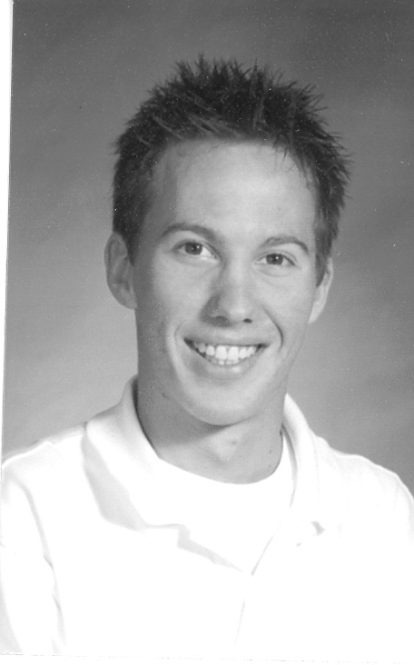
CHRISTOPHER JANUS was born in Philadelphia, Pennsylvania and raised in a small resort town located two miles outside of Ocean City, New Jersey. Born to Polish parents, he was taught his heritage first hand and speaks fluent Polish.

While growing up, Christopher traveled to Europe often and was heavily into paintball and motor cross. As a freshman in high school, he began to play soccer for his school team and also played for a national amateur paintball team.

“Working hard towards my goals is something my parents taught me and is something that will be with me for the rest of my life.” Christopher’s goal now that he has graduated high school is to finish his secondary schooling in four years and become a Certified Public Accountant.

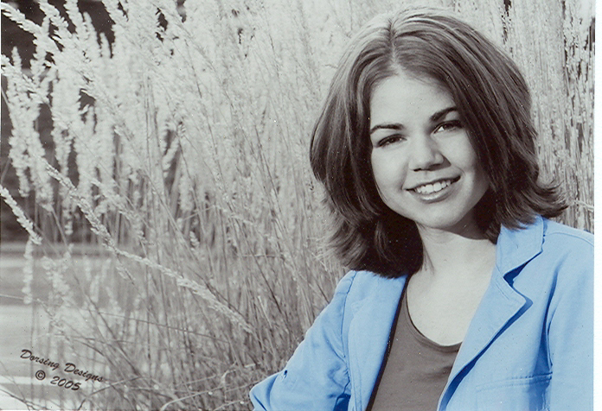
LAURA WIEST graduated number one in her class at Eisenhower High School in Yakima, Washington. As a senior she has taken a full year of accounting, and through the class decided to focus on a career as a Certified Public Accountant.

Laura was involved in her high school chapter of Future Business Leaders of America and finished third in accounting at the state level. In June, she competed at the National FBLA conference in Orlando, Florida.

This coming fall, Laura will attend Seattle Pacific University, where she plans to major in Accounting.

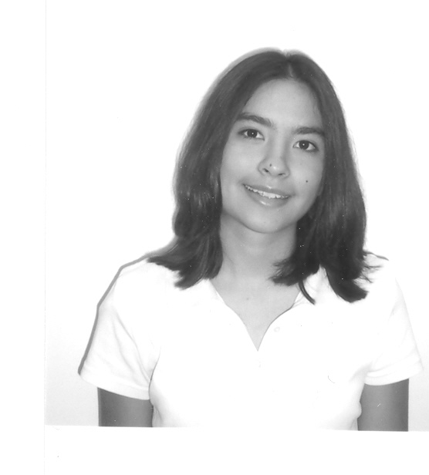
JESSICA E. DIAZ was born and raised by immigrant parents and has had the privilege of being exposed to different cultures. Her interests include music, tennis, biking, traveling, and spending time with friends and family.

In the fall, Jessica will attend the University of Southern California. She is very excited for what the future holds.

The National Conference of CPA Practitioners (NCCPAP) is an association of CPA firms in public practice committed to quality and integrity for the profession. Established in 1979, NCCPAP is the only national organization representing only CPA practitioners. Members work actively with Congress, the IRS, state legislatures and taxing authorities to develop and define tax policy and legislation. For more information, visit the website at www.nccpap.org.

# # #
061605

